**Section 12 done: 14/14 Adding Routing to our Burger Project  
Building the Checkout Container**  
* I will actually implement this as a container because it will be a component which manages its own state and also passes this down to toher components.  
* Creating `Checkout` folder with Checkout.js and `Order` folder with CheckoutSummary.js.  
* The DIV after h1 is required to set the boundaries of the Burger component.  
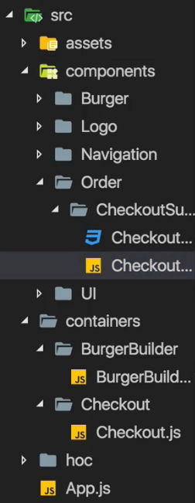   
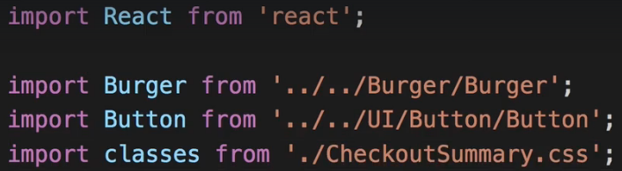  
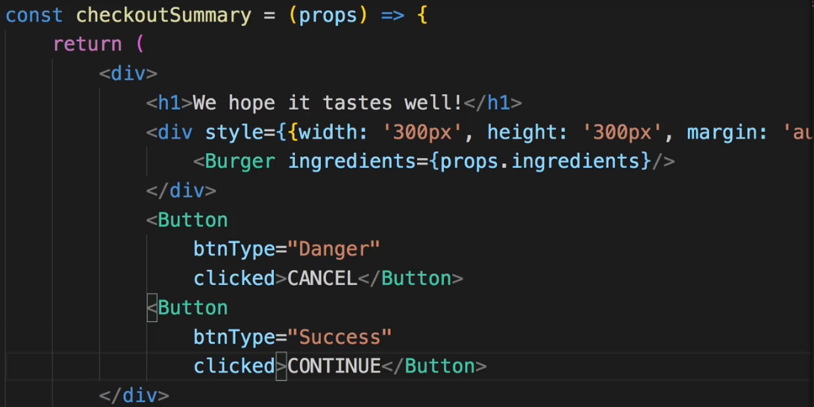  
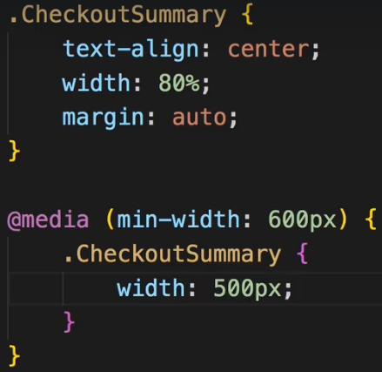  
* We expect `ingredients` prop in the Burger so we should get it in CheckoutSummary.js too.  
* We import Button.js which takes a prop `btnType`. We also know that the buttons expose the `clicked` prop which simply indicates that we clicked on the button, we will add that later, for now we’ll just finish the styling of this component.  
* And we add the class using CSS Modules:  
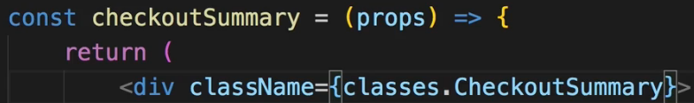  
* So with that we got our CheckoutSummary JSX code.  
* Now we want to use the CheckoutSummary component in our Checkout container.  
* Keep in mind CheckoutSummary expects to get `ingredients` as a prop.  
=> That of course is an interesting question - where do I get my ingredients from?   
* For now I will place a dummy object as ingredients but I’ll replace it later.  
* I’ll add STATE to the Checkout.js component and in there for now hard-coded ingredients.  
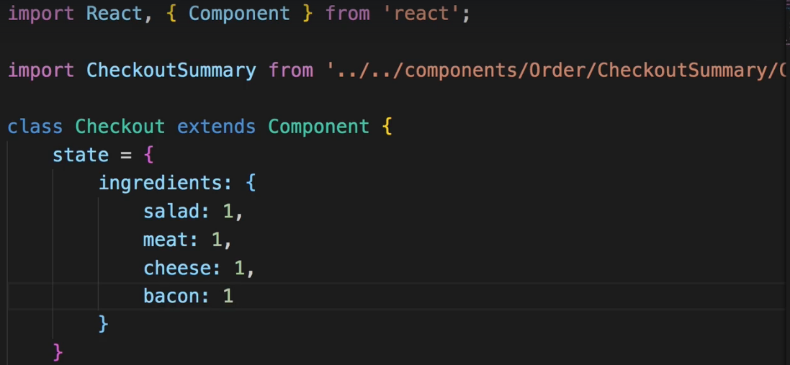  
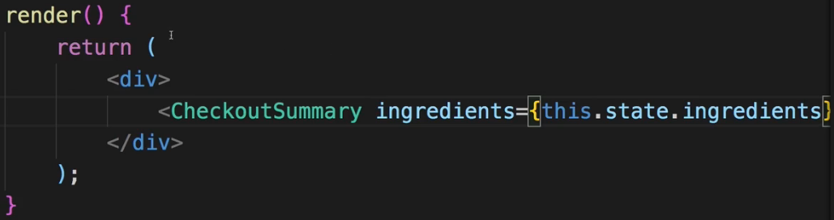  
=> We will have to use ROUTING to really pass ingredients later.  
* Now we got the CheckoutSummary.js component and the Checkout.js component, now I want to use it of course.  
=> And for that I will hard-core it into my App.js file right below the BurgerBuilder.js.  
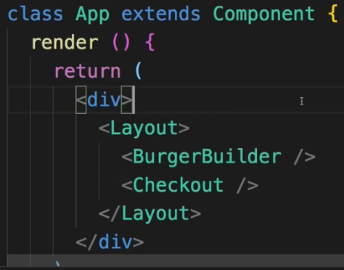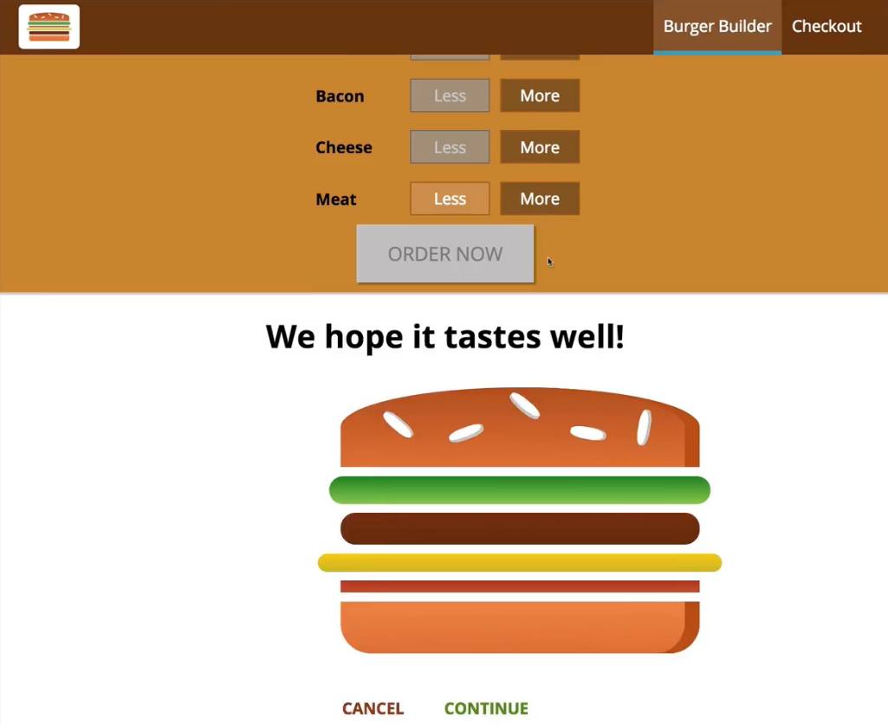  
* Now of course we get an error regarding our click handler.  
* Now we can see that somehow this DIV with the burger is not really centered, we can adjust that by using width: 100% in the inline style of the checkoutSummary DIV.  
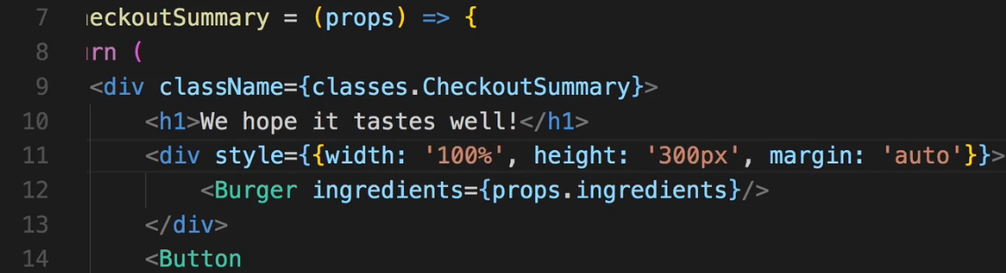 * Let’s get rid of the height too.  
* The main thing I now want to work on is that I don’t always display this but instead this should be displayed if I click on ORDER NOW, CONTINUE then I want to load the CheckoutSummary instead of the BurgerBuilder, that’s the goal.  
**Setting Up Routing & Routes**  
**npm install --save react-router-dom**  
* If you install react-router too, it’s not increasing the bundle size.  
* I’m going to use BrowserRouter in index.js file though you could do it in the App.js file too. I want to wrap my whole app though so I’ll do it here.  
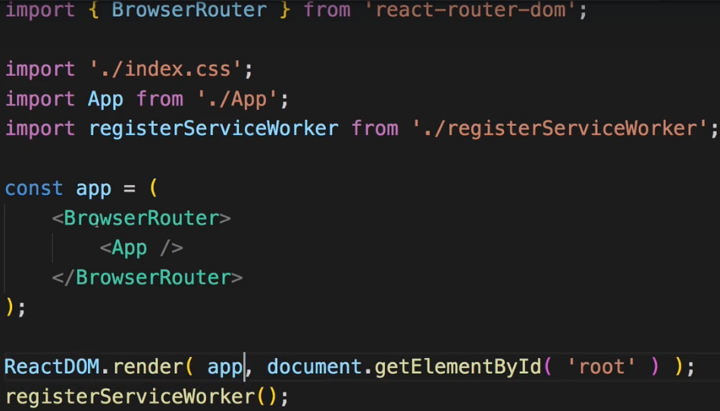  
* Now let’s set up some routing in App.js which is where we load both BurgerBuillder and Checkout.  
* If we use “/” and “/checkout”, both will render, to prevent this we can use the `exact` keyword or we use the Switch component to wrap our Route-s to only get 1 hit but then we also need to change the order so that “/checkout” is above “/”. With `exact` the order doesn’t matter.  
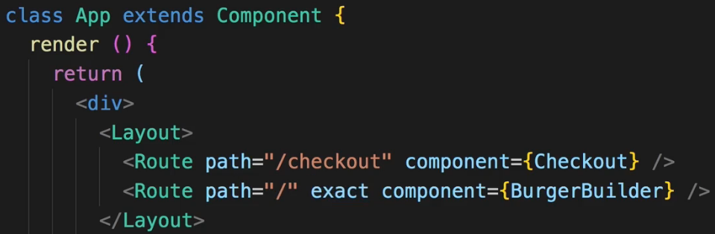  
* The next step is to make sure that when we click on CONTINUE in this Modal, in OrderSummary, that we also navigate to “/checkout” so that we can see that route instead.  
**Navigating to the Checkout Page**  
* Right now purchaseContinueHandler in BurgerBuilder.js is where I set loading: true and where I then place my order and send it to the web. I’m going to comment all the code out because I no longer want to store it on Firebase immediatelly - I want to go to the Checkout component instead.  
* BurgerBuilder.js is loaded through a Route and everything which is loaded through a Route but only the direct component - so only BurgerBuilder itself gets these special props.  
* Components nested inside BurgerBuilder don’t get them, we would have to pass them on manually.   
* There is a way we could still get the props in the Burger.js component too though - and this really is a bit advanced and not something we need here but I want to show it nonetheless.  
=> If we use a special HOC - Higher Order Component provided by react-router-dom, we can actually kind of inject/make them available these special props in any component.  
=> **withRouter**.  
  
  
=> And wrap the export with it.  
=> Now `match` will refer to the nearest `match` so to the nearest Route which was matched in the past, in this case the Route which matched the BurgerBuilder.  
* Now beck to BurgerBuilder.js, the purchaseContinueHandler method.  
* `this.props.history.push()` allows us to basically switch the page and push a new page onto that stack of pages.  
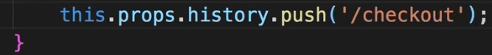  
**Navigating Back & To Next Page**  
* So we can visit the Checkout page, on the Checkout page let’s make the buttons which are part of CheckoutSummary - the CANCEL and CONTINUE buttons.  
* This is what Checkout.js looks like.  
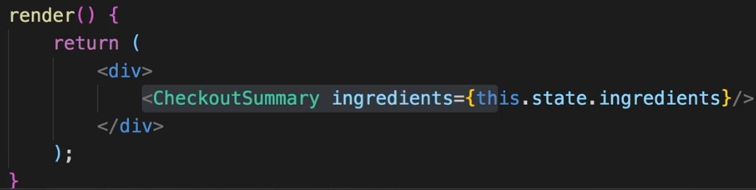  
* This is CheckoutSummary.js.  
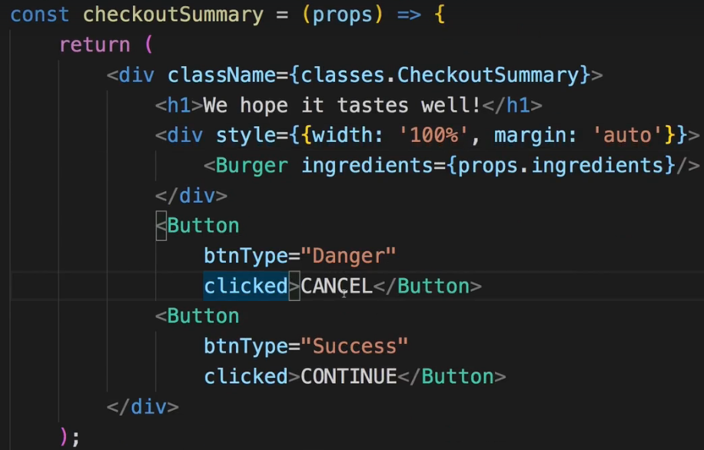  
* Now these buttons are of course in the CheckoutSummary, I could handle them there by turning the CheckoutSummary into a class but I just want to expose this event basically in the Checkout container which wraps the CheckoutSummary component.  
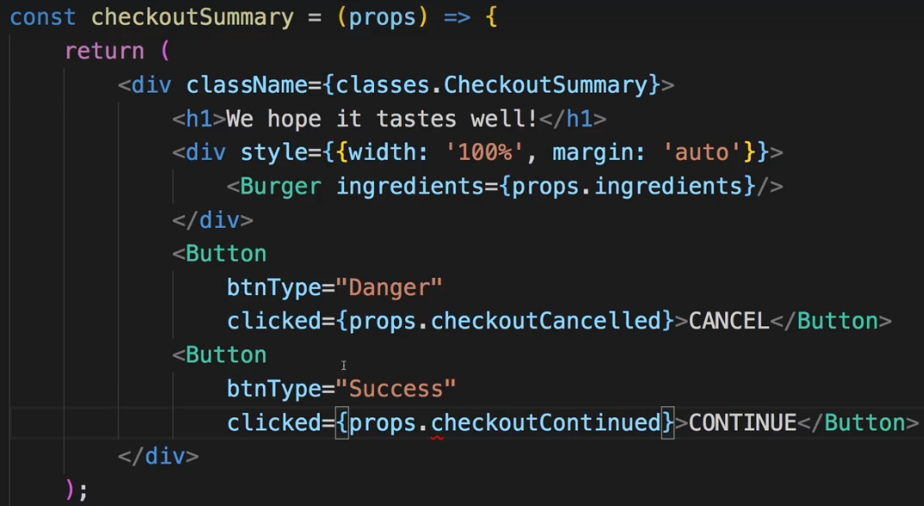  
* Now in Checkout.js we implement these methods.  
* Using the arrow method syntax to be able to use `this` keyword inside of there.  
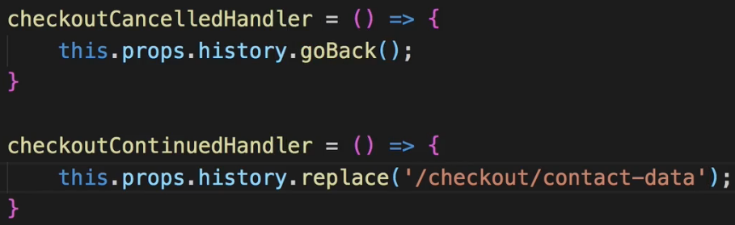  
* We don’t handle this “/checkout/contact-data” path yet but this should be path which soon loads the ContactData component, which we don’t have yet again.   
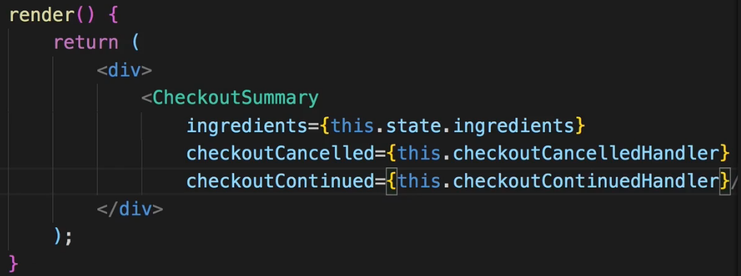  
* Now if I click CANCEL, it takes me back to the burger builder.  
* If I click CONTINUE, the URL changes but of course that doesn’t do anything because we’re not handling it yet. So this is something I will have to handle in the future.  
=> The thing I want to do before handling that though is that I want to render the burger I really built in the checkout and not just a premade burger.  
=> To render the burger I actually built, I will have to pass the respective data about my burger to the Checkout page, so from the BurgerBuilder pass the data about the ingredients onto the Checkout.js.  
=> Now I want to pass the data on via **Query Params** here.  
**Passing Ingredients via Query Params**  
* I will do this in BurgerBuilder.js where I push() to the “/checkout” page.  
* There I now want to push() a JavaScript object.  
=> There I specify a `**search**` parameter, a search query which is how I want to pass the ingredients.  
=> **encodeURIComponent()** which simply encodes my elements such that they can be used in the URL.  
  
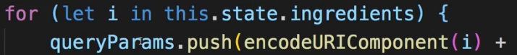  
=> Setting property name = the value for that property name.  
=> So this is an array which now just has a couple of strings, which is propertyName=propertyValue.  
=> Now this array of strings is what I want to .join() with an & sign.  
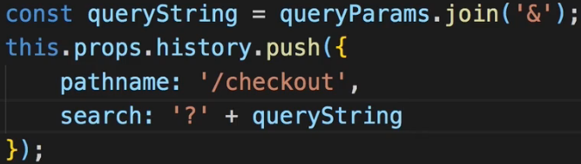  
  
* Now of course I need to parse this in the Checkout.js component and there I’ll do it in **componentDidMount()**. I won’t use componendDidUpdate() or anything like that because whenever I load this component, it will mount itself, there’s no way I can route to it without it being mounted again because it’s not nested in some other page or anything like that.  
=> **new URLSearchParams()**.  
=> `this.props.location.search` includes the ? and so on but with URLSearachParams() I can extract that.  
=> Each entry will have this format: [‘salad’, ‘1’].  
=> `ingredients[param[0]]` which is just a name like ‘salad’ which is then used as a propertyName and added to the ingredients object and now comes the value which is just `param[1]` param element 1 and we can convert this to a number by adding a `**+**`.  
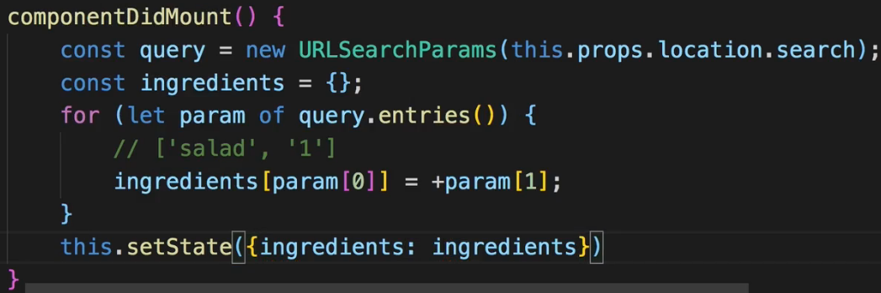

=> Now we see the actual burger we built when click ORDER NOW, if now in the browser we for example change some query parameter, it works as well.  
**Navigating to the Contact Data Component**  
* ContactData will actually be a container, not only because it’s loaded via routing but because it will manage its own state, especially once we cover forms in React.  
* Creating `ContactData` folder inside `Checkout` folder.  
* I will not really work on the form, I will not finish it in this module because we’ll have a whole module about forms and validating forms after this module.  
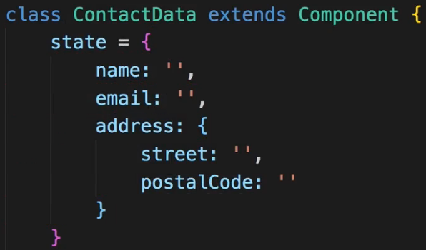  
* Let’s just create a quick form here.  
* We’ll later add a click listener to the button.  
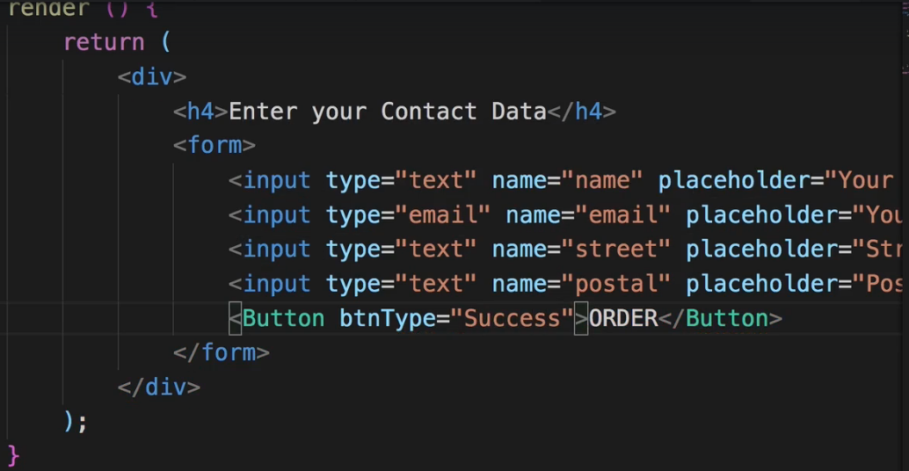 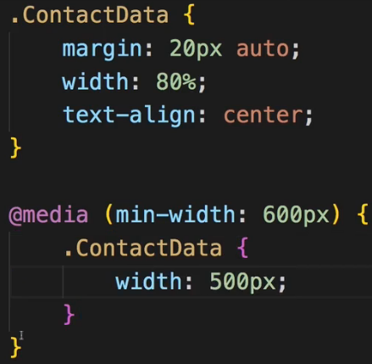  
* To add it some styling, I’ll add a `ContactData.css` file and of course you could also create a sub-component which handles the styling if you wanted to do that.  
* Now we want to load this ContactData via routing, we will do this in the Checkout container.  
* It should be a nested route below the CheckoutSummary so it should not replace the CheckoutSummary though we could of course do that, instead I want to load it below there, also to show that this is something that you use in reality too - nested routes.  
* Now you can use `**this.props.match.url**` or also for building paths and routes, you might use `**this.props.match.path**` here.  
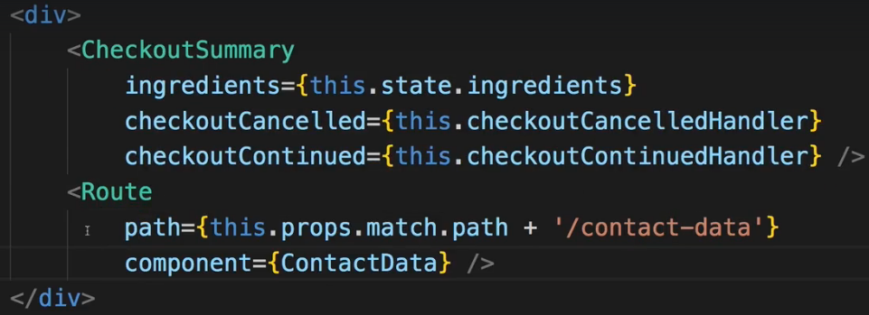  
* Now when we click CONTINUE, the query params are gone in the URL but the burger is still there because even though the query params are lost, it doesn’t overwrite the old state because we did setState() and it doesn’t re-render this component as you learned so therefore componentDidMount() where we built the burger, where we set the state depending on the query params, isn’t running again just because we loaded a new component. So that is why the burger still looks like this.  
* Now improving the styling of the ContactData a bit.  
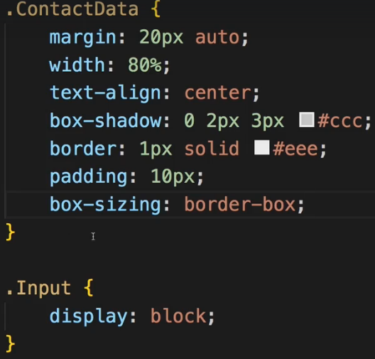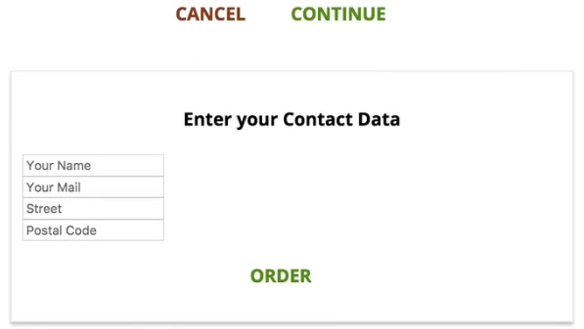  
* The next step is to make sure that when we click the ORDER button, we actually do send this Request to our server.  
* Now getting the ingredients into the ContactData.js component now is kind of tricky.  
**Order Submission & Passing Data Between Pages**  
* In ContactData.js:  
  
* We need access to the ingredients in the ContactData to make this request.  
* And here’s a little trick I want to show you.  
* I taught you all the building blocks you need for that but it might still not be straightforward to be honest.  
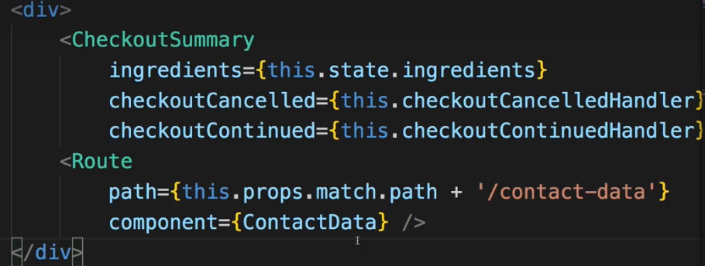  
=> In the Checkout.js container, where we include the ContactData component, I somehow want to pass the ingredients which I do have in this component, to ContactData.  
=> Now for this I won’t use the `component` property on Route but the `render` property which takes a method where you then output some JSX. And there I actually want to render the ContactData element.  
=> Since I now render it manually here, I can pass props to it.  
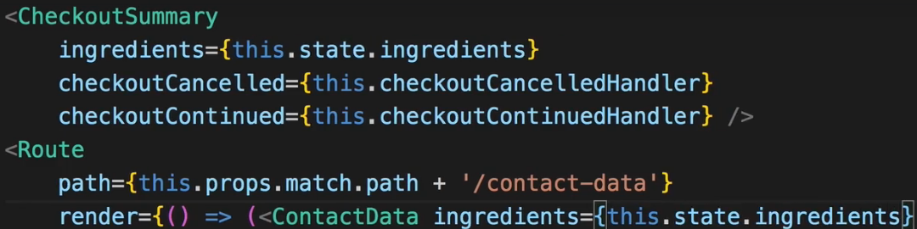  
* In ContactData.js we need `**event.preventDefault()**` because we don’t want to send the Request and reload the page as it otherwise would.  
* I’ll cut and paste the code for sending the Request that I commented out in the BurgerBuilder.js purchaseContinueHandler.  
* And add a loading: false to the state in ContactData.  
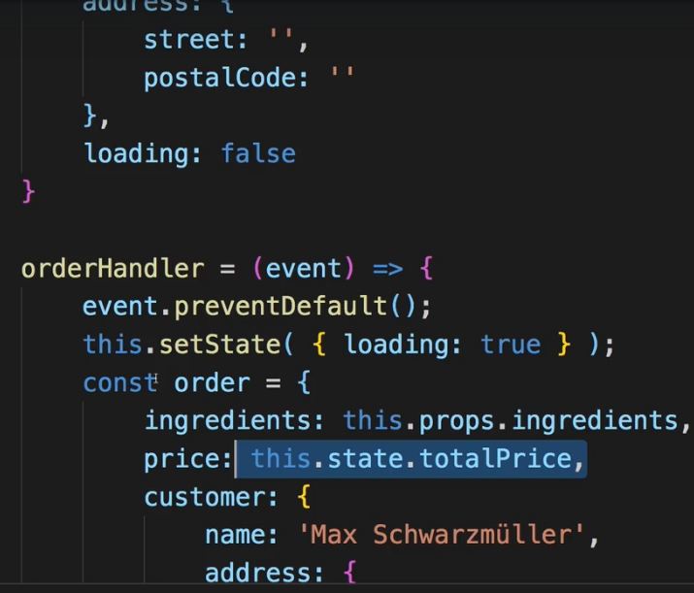  
* Changing this.state.ingredients to this.props.ingredients.  
* The price here is a different story, the total price here is difficult because right now the total price is only calculated and stored in the BurgerBuilder.js.  
=> So we have to pass the totalPrice along with the ingredients from the BurgerBuilder.js to the Checkout.js container.  
=> So in BurgerBuilder I’ll simply .push() it to the query params.  
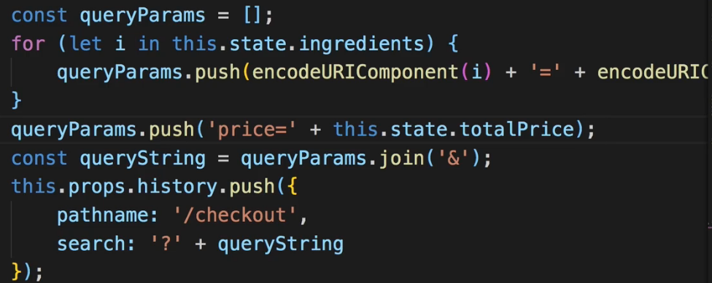  
=> This of course also means that I have to get it inside my Checkout.js component.  
* Now in Checkout.js we’re looping through all the ingredients and then I’m pushing them onto my ingredients array. The total price of course is not an ingredient so I shouldn’t push it onto this array.  
=> We’ll check if param[0] === “price” - this is just a workaround, we’ll find a better way of handling this STATE and passing it to this other container later in this course.  
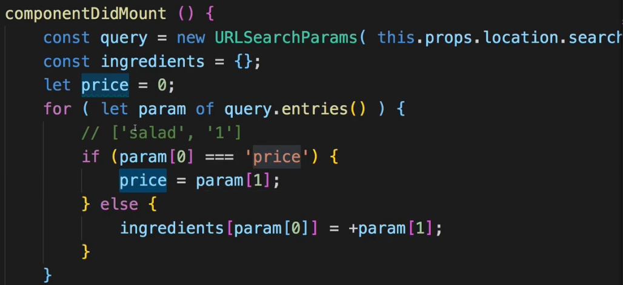  
  
* Let’s also initialize price in the state.  
* By the way, ingredients can now be intialized with null.  
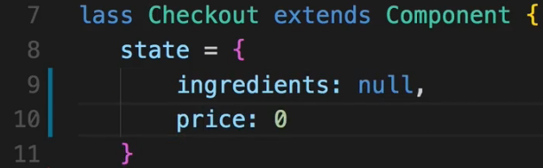  
* Now this was the way of getting the price in the Checkout.js, now I want to pass the price onto the ContactData.js just like the ingredients.  
  
* In ContactData.js now.  
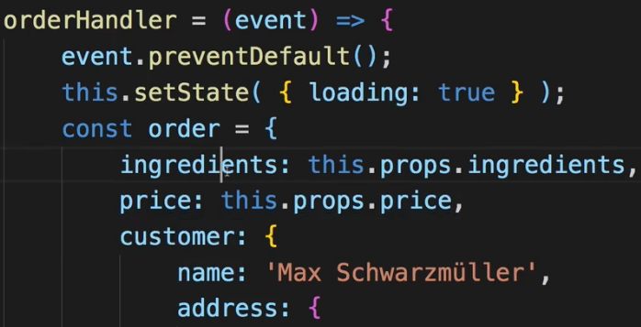  
* Now the other part here I could already connect this to my inputs but I don’t want to do this right now, we’ll do it later. For now I’ll leave all that data here as it is.  
=> Now we get an error regarding the ingredients:  
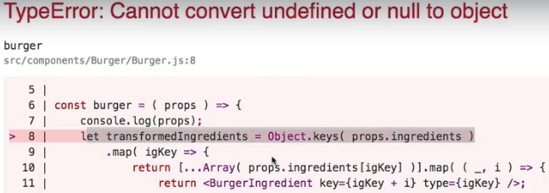  
=> The reason for this is that we extract the ingredients here in the Checkout.js but we actually do this here:  
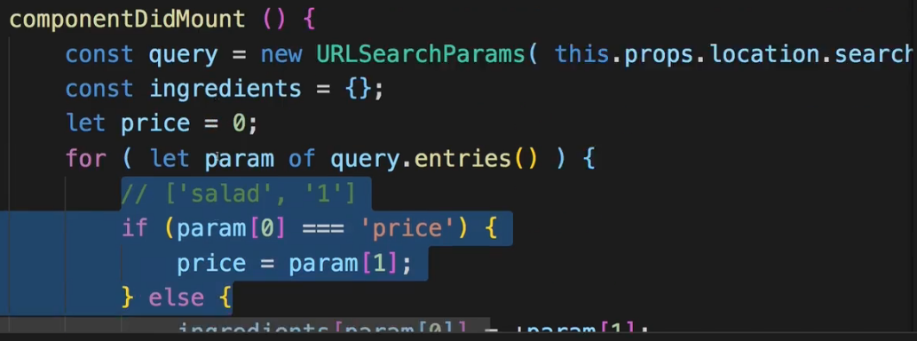  
when we initialize the state.  
=> The initial ingredients here are null though and if we pass that to ContactData and we try to render the burger there, this doesn’t work with ingredients that are null.  
=> Now to fix this we can simply change the **componentDidMount()** to **componentWillMount()** so before we render the child component, we already have access to the props there so we can already get the query params there but we do this at the point of time where we don’t render the children so we can set up the state prior to rendering the children.  
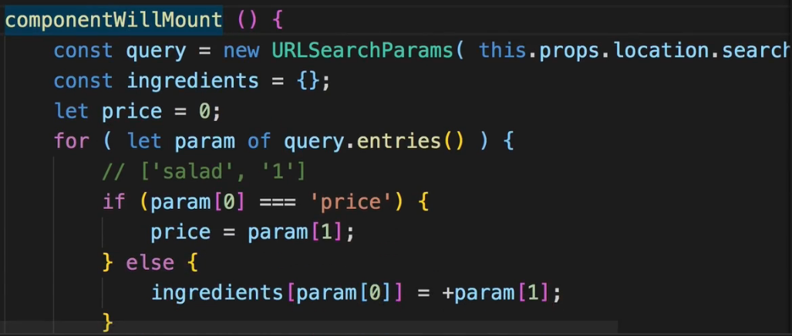  
* Now it should all work.  
* Now one thing I want to do is this `purchasing` state:  
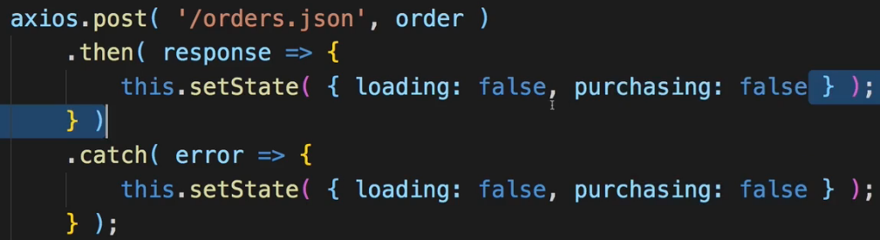 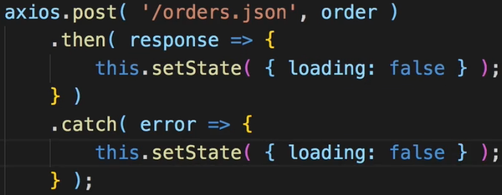  
which I’m setting here is not required anymore.  
* `loading` is a state I don’t use yet   
=> Now if we click ORDER we don’t get a feedback here but if we check our Firebase database, we see this new order being placed at the end here.  
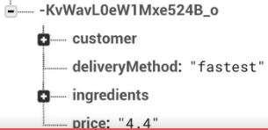  
* Now let’s take advantage of the `loading` state and showing a Spinner.  
* And redirecting the user once we’re done.  
=> To show the Spinner:  
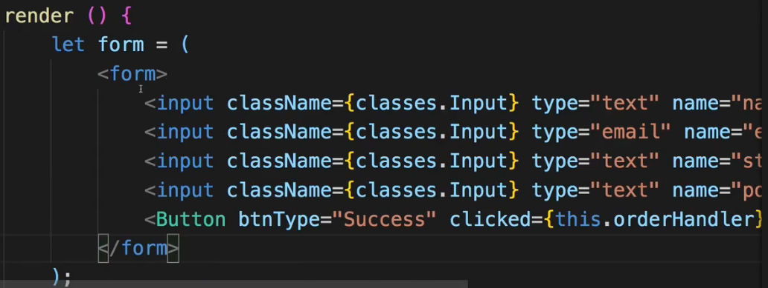  
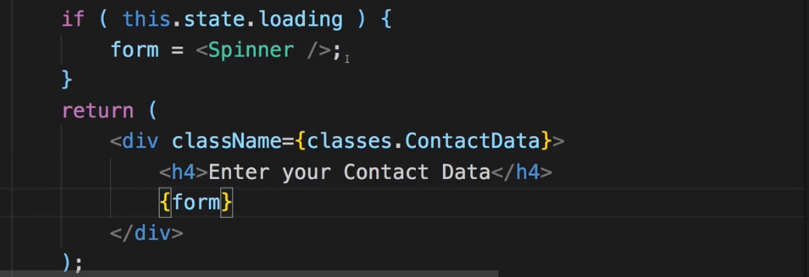  
* Now in order to redirect here, normally, we could run `**this.props.history.push(“/”)**`. However, due to the way we’re loading ContactData, by basically rendering it manually with the `render` method, we don’t have the `history` object available in there.   
=> Now there are 2 ways we can use to fix this.  
=> 1. => We can wrap the ContactData component with this `**withRouter**` helper method.  
=> 2. => The other would be to pass `history` and so on which we do get in the props of this `render` method here in Checkout.js, onto ContactData.  
=> Now I will use the props I get in this `render` method and I will simply distribute them here after passing my own props with **{…props}** whatever I get in the props here will be passed on to the ContactData and therefore, since this will include the `history` object, this `.push()` method here should work.  
  
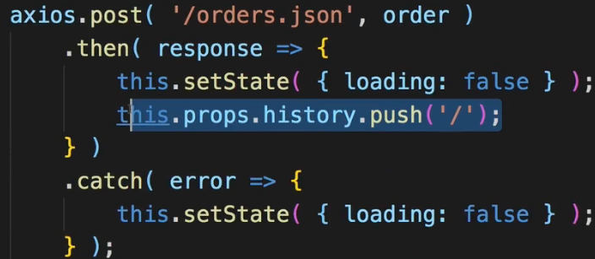  
* Now if I click ORDER it does indeed push me back to the starting page.  
* So this is the checkout page and process finished, of course still some stuff we can do there regarding the form especially, but we’ll take care about this in the forms module.  
* Now let’s focus on the My Orders page.  
**Adding an Orders Page**  
* Creating `Orders` folder inside `containers` folder.  
* The question is what do we want to render in there - I want to output my orders in this page obviously. For that I’ll create a new component in the `Order` component folder (we have `Order` folder in `components` and `Orders` folder in `containers`).  
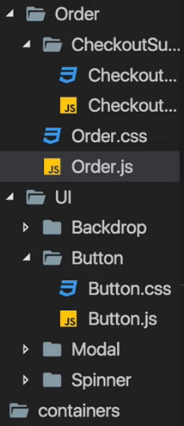 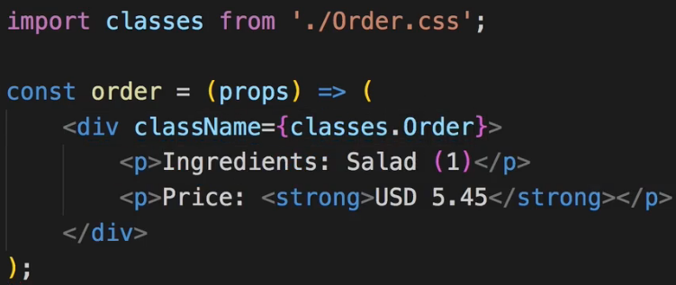 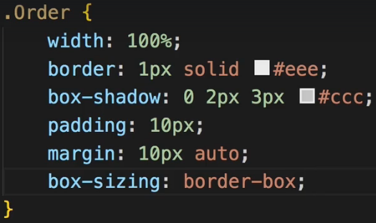  
=> This is what it should look like, obviously we’ll use props to output the values.  
=> Now this is what 1 order should look like.  
=> In the Orders.js obviously we want to output multiple orders, actually as many orders as needed.  
=> And the orders I need to output of course should be fetched from the Back End.  
* In Orders.js let’s just output 1 dummy order.  
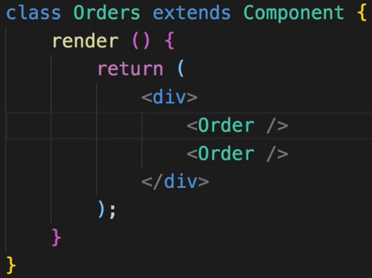  
* Now before we populate this with real data, let’s load this Route.   
* And the Orders.js page should of course be loaded instead of the BurgerBuilder or the Checkout page.  
=> So it’s in the App.js file where we set the Route-s up where I also want to set up a Route for the Orders.  
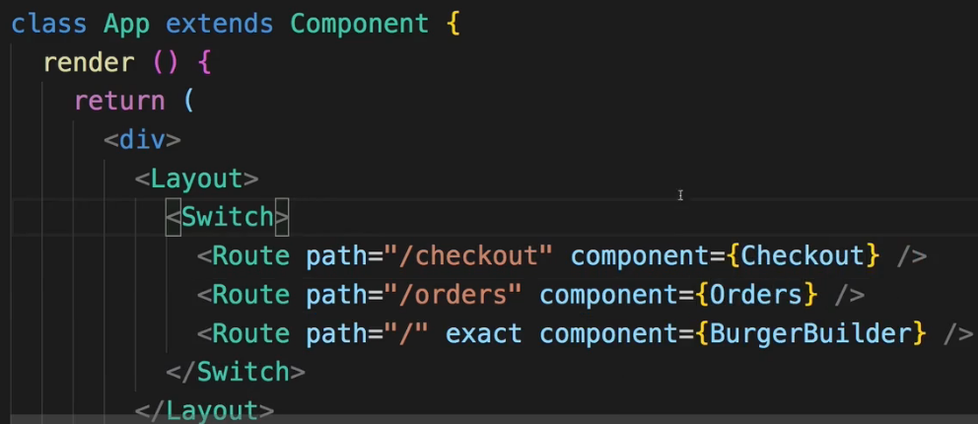  
* Now to view this Route, we’ll have to do something which we haven’t done yet - we have to add a Link and for that we actually have to touch our `NavigationItems.js`.  
**Implementing Navigation Links**  
* This is what we had in NavigationItems.js:  
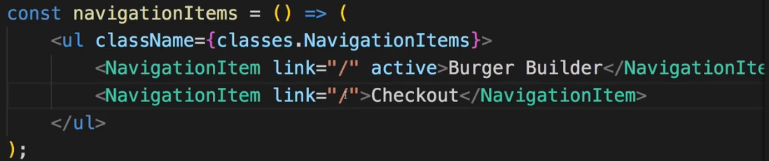  
* Let’s touch our NavigationsItems.js and adjust them to our routing.  
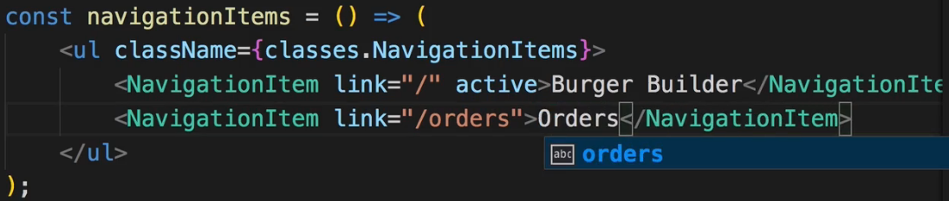  
* In NavigationItem.js this is what we had:  
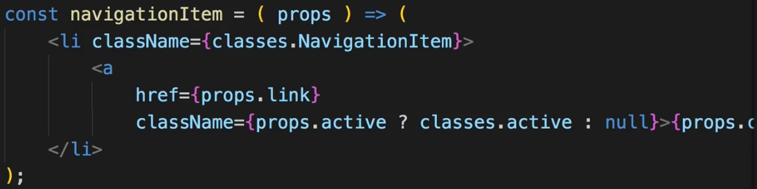  
=> Now inside NavigationItem.js we also have to adjust something.  
* Right now we’re using a normal anchor tag <a></a>. Now as you learned, when using routing I don’t really want to do that. Instead, I want to use the Link provided by the React Router.  
* I’m going to use NavLink because I want to style the active link and actually I want to use the default of having a CSS class named “active” because that’s the CSS class I have defined in my CSS file too, you can of course choose a different name and adjust it as shown in the routing module.  
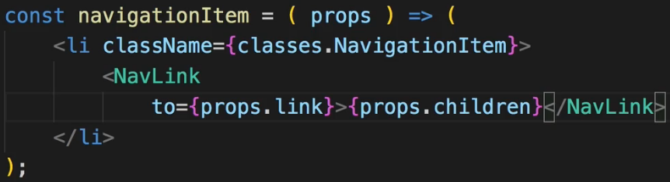  
* Now that we don’t need to pass the information whether it’s active or not, we can go back to the NavigationItems.js and I no longer need to set this `active` prop here.  
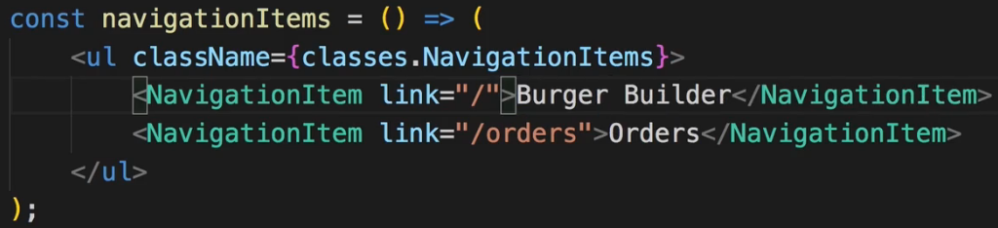  
=> Now if we check our application, we don’t see an active item.  
=> If we hover over this item, we see that it does have the “active” class.  
=> This is tricky to spot but it makes perfect sense that we don’t see this class having any effect.  
=> It is related to CSS Modules - keep in mind the NavLink automatically appends/attaches a class named “active”. And of course we set up an active class here in NavigationItem.css.  
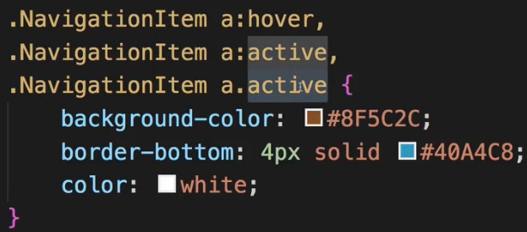  
=> **But keep in mind that CSS Modules will actually take our class names here in the CSS file - “active” and convert them into unique class names, it will have some hash and it will be unique**.  
=> **Therefore “active” class attached at run-time by NavLink won’t match our unique “active” class**.  
=> We can easily fix that though - the NavLink element has 1 extra property we can set up.  
=> We can set our own `**activeClassName**`.   
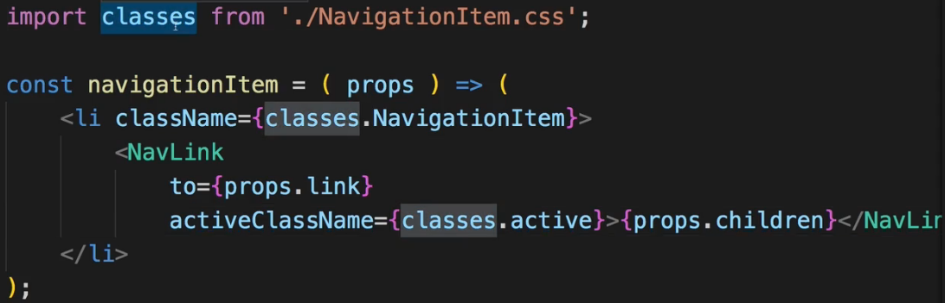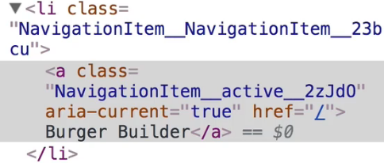  
=> Now if we click on Orders, you see we are on Orders, it is active, but the first link also is still active.  
=> This Burger Builder is of course also active due to the way this NavLink interprets the active Route.  
=> Keep in mind that the `**to**` path here is what determines whether this is the active Route or not. And it’s treated as a prefix.  
=> So we can simply fix this by adding the `**exact**`.  
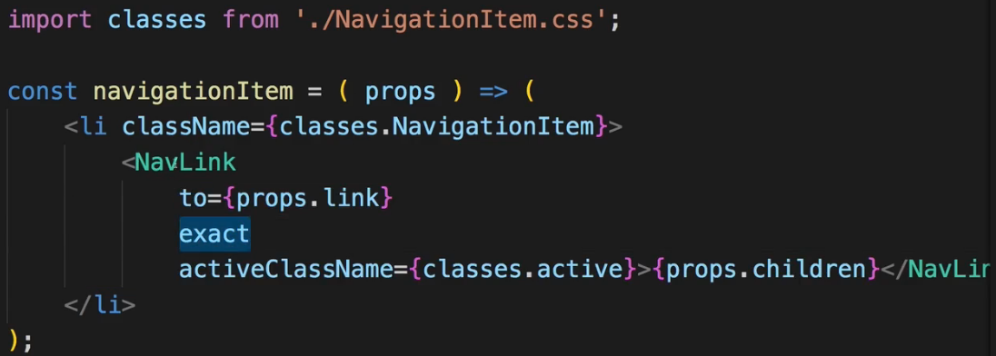  
=> Now this of course will attach `exact` to all NavLinks.  
=> **If you only needed somewhere this should happen, you could simply pass the `exact` property to NavigationItem and in NavigationItem.js you can now bind the `exact` prop of NavLink to props.exact so to the one you’re passing in from outside**.  
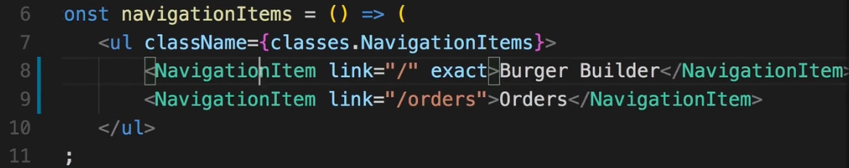  
=> Now this will actually only be used on the first link with just “/” and not on the second with “/orders”.  
**Fetching Orders**  
* In Orders.js container I obviously want to fetch my orders.  
=> To do that I will implement **componentDidMount()**. I can use componentDidMount() here because I only want to fetch orders when this is loaded, there is no way we will go there without   
re-mounting it so componentDidUpdate() is not what I’m looking for.  
* I’ll add a STATE with orders array empty array and loading true initially.  
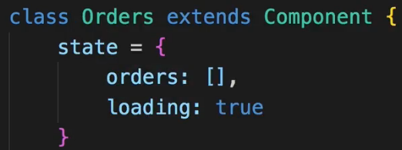  
* Now the thing is when I reach out to the orders node in Firebase, I’m not getting an array but I’ll get back a JavaScript object.  
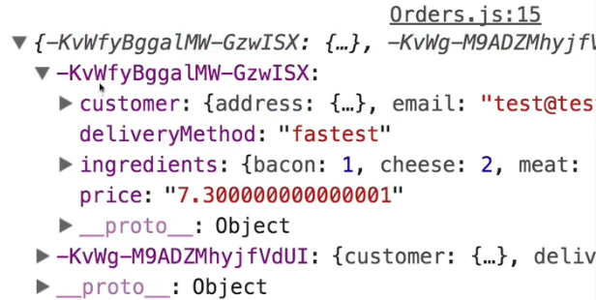  
=> As you see it’s a JavaScript object where the keys are simply these unique IDs Firebase generated for us and the value then is the individual order data.  
=> Now I want to turn this object into an array.  
=> I can simply do that by using `**for in**` loop.  
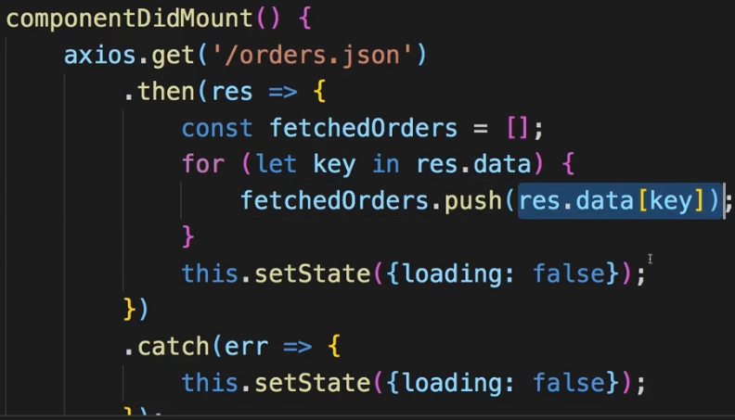  
=> This will push the order into that array.  
=> To not lose the IDs though which are my keys here, I’ll not .push() this object, I’ll instead .push() a new object onto this fetchedOrders array where I’ll distribute the properties of the order object I fetched from Firebase with the spread operator and add 1 new property `id` which is the `key`.  
* So now I have my fetchedOrders array full of order objects which also are aware of their IDs.  
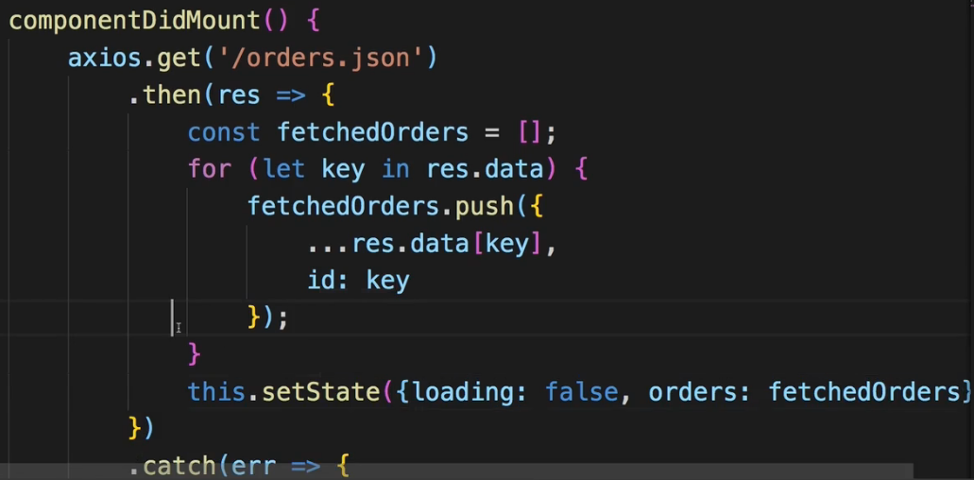  
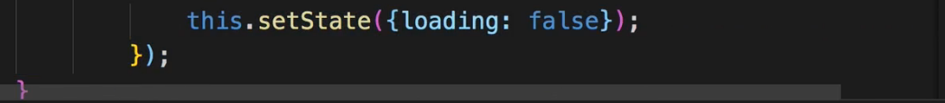  
* I of course also want to handle any potential errors, so I’ll import my own HOC withErrorHandler and wrap our Orders component with it in export.  
  
* Now of course fetching orders is not the same as outputting orders. So let’s do this next.  
**Outputting the Orders**  
* Let’s now loop through our fetched orders and output them.   
* I’ll do it inline here.  
=> We’ll map our `this.state.orders` array into the array of JSX elements.  
* In Orders.js:  
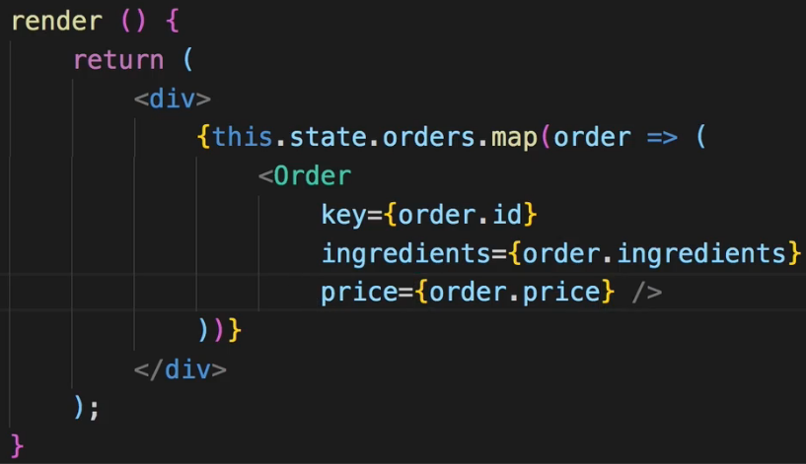  
* **Number.parseFloat()** to convert a string to a number.  
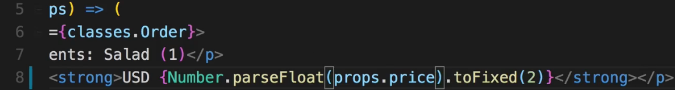  
* Or you add a **+** sign at the point of time you’re passing it here in the Orders.js like this:  


* Now ingredients are an object and we need an array to loop through them and output them.  
=> You can do that conversion either in the Orders.js container or here in the Order.js component.  
* We used the same logic in Burger.js.  
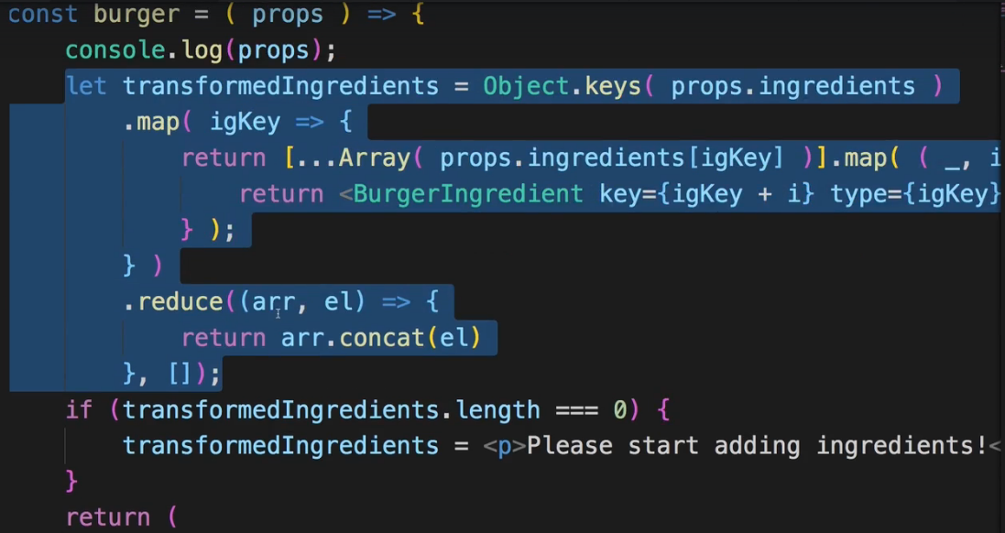  
* I want to show you an alternative though.  
  
=> This is what I can do, because in a `**for in**` loop, the variable element is going to be the property name and since my properties are simply just ingredient representations, ingredientName makes sense to me.  
=> I want to .push() an object where I have the amount but before storing the amount, I also want to store the name of the ingredient.   
=> This transformation is shorter than the previous one.  
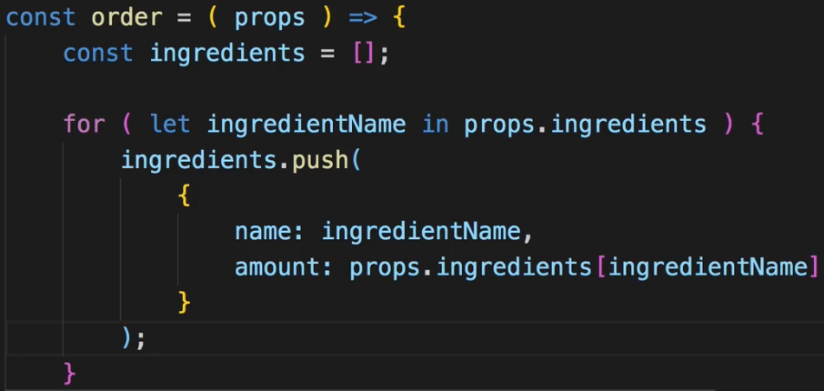  
* Now with that being pushed onto the ingredients array, I can map my ingredients to text here basically.  
* I can use the ingredient name as the `key` as it is unique here.  
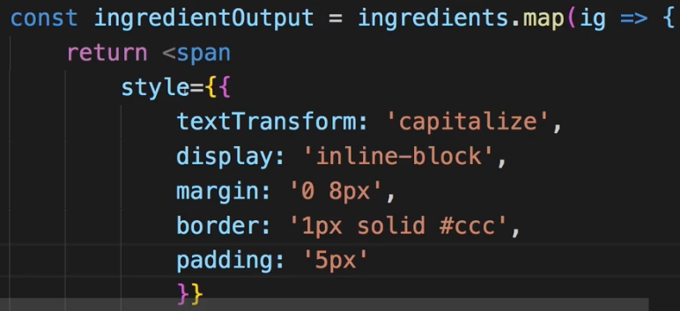  
  
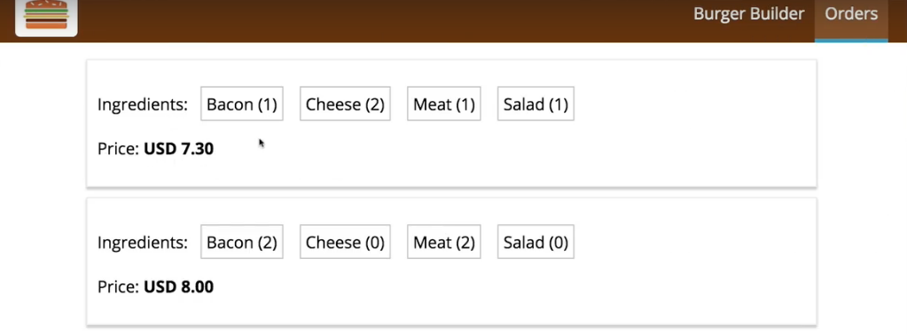  
* You could of course you a CSS class instead of inline style.  
* Now we can add more logic to the orders, we can add logic to delete an order or to mark it as fulfilled. For now, this is how I want to output them though.  
**Wrap Up**  
* We can improve the checkout form.  
* And we can improve in general the STATE management of our application.  
=> We can already see that we have to use some tricks and workarounds from time to time.  
* Let’s now dive deeper into FORMS and then additional features the React ecosystem offers to us.